Sycilian jobs
Sicily and its territory
Sicily can be defined as an island between sky and sea, with a strategic position in the middle of the Mediterranean sea, and always a destination for many tourists every year. This unique territory, whose landscape develops in a continuous alternation between hills and plains, has always known how to welcome great civilizations that still today give tourists strong emotions and the charm of the discovery of a great passatotra from the Phoenicians, Greeks, Arabs, Normans and of all those civilizations they had
found in the "Island of the Sun" a paradise.
The economy of the region remained, however, mainly based on traditional production activities, of small dimensions and not very competitive, usually linked to the agriculture sector.
The typical foods of Sicily, famous and famous all over the world, are really numerous. Just think of cheeses, cured meats, olive oil, olives and artichokes, sun-dried tomatoes, to name just a few of the exquisite food and wine delicacies of our island.

Typical Sicilian dishes are enriched with aromatic plants such as oregano, basil, garlic, mint, bay leaves and chilli that give that extra touch, something meaningful and unmistakable to our cuisine in a triumph of flavors and aromas.
Finally, in a good Sicilian meal you cannot miss the typical Sicilian pastry desserts: cassata, cannoli, almond desserts, etc.

1-the pasta maker
The sectors identified belong to the traditions of the activities: agricultural, ax masters, music, folklore, storytellers, stone working, construction of Sicilian carts, handicrafts, construction of traditional boats, seafaring culture, folk songs, cooking, Sicilian puppets.
The goodness and quality of fresh Sicilian pasta is the basis of the success of this profession.
Quality is guaranteed: it is a handmade product, natural and worked according to the tradition of the land of Sicily. A pasta that comes from the passion for good food and from the respect for the traditional and fresh product. In pasta brings the true flavor of fresh egg pasta to your table.
Everything comes from bronze drawing, which accentuates the taste of fresh pasta giving it the typical roughness that helps the pasta retain the seasonings.
The pasta, then, is made using only Sicilian products, from fresh eggs of the day to semolina, produced in local mills. In this way the company combines respect for the Sicilian tradition with the quality of the products of our land, products that do not contain any chemical preservatives.

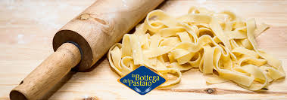

2-Farm laborer
In Sicily, the farm laborer is a worker who lends his arms as a labor force in the countryside in exchange for a salary in kind or in money, so to those who work the land directly under the ownership of a landowner or whoever he took the place (in this case it could have been a "massaro", also called "massaio").

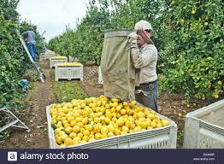
3-The fisherman
The fisherman is in charge of catching fish for food purposes. He plays a very important role in the supply of resources and is a witness to the Italian fishing tradition, a sector to which numerous excellences of the Sicilian territory are connected.
Nets, traps, a lot of audacity and knowledge of fish habits are the tools of the fishermen of the area. The nets and the traps more than works of specific artisans are the result of the sacrifice of the fisherman or of the members of his family, even if the weaving of the traps or the weaving of the nets requires a particular mastery, which could make us think of specific artisans. For the nets once hemp or cotton was used, this type of material needed a lot of maintenance, in fact it happened that some fish remained between the meshes of the net and rotting determined the laceration of the same one and the fisherman was forced to mend using one special needle "vugghiola" in which the cotton or hemp thread was wrapped, now instead nylon thread is used, which is much more resistant and less attackable than natural fibers. There are different types of nets, which take on different names depending on the type of fishing carried out: drift nets (alalungara); encircling networks ("u cianciolu"), which at one time had a length of 250 m and are now woven of 1000 m; mail networks without drift tremaglie or "rrizzuolu"; "a stràscinu" trawl nets like the paranza. For the construction of the traps the raw material is made up of the rush (called iuncu munti), usually imported from the province of Catania. It is necessary to keep it in water for 24 hours before starting to weave it so as to form the small rhomboid meshes typical of the traps, which will be used in the so-called minor fishing. In making the traps the fisherman begins the weaving of the external bell, whose terminal ring is made up of a wild olive rod, then proceeds to the weaving of the inner part, in the shape of a funnel: the terminal threads of this part will form the link trap that prevents fish from escaping once they have entered the trap. Let the bell and funnel match perfectly, the nassaru proceeds to the final weaving of the lid. The pots in the area were used above all for the fishing of the "asineddi", type of maenide (maena smaris). To fish this species it was necessary to know the cycle of the species, in fact the most propitious period was between March and June, period in which it is in the season of love "u varu", the skill of the fisherman consisted in identifying the herd among the backdrops of "rinazzuolu", which is formed more from soil than from sand.

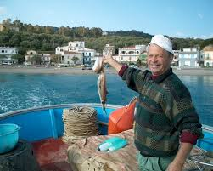

4-POLYFUNCTIONAL SPECIALIZED WORKER
It is a particularly delicate figure because it contains cultural aspects and
deep psychological; for example, in today's productive quality context, a practice in progress
of diffusion as that of the thinning of the bunches before the harvest (a form of
"green" pruning able to lead to more concentrated products) constitutes a real one
innovation that is simple to carry out in practice, but that requires an awareness not
accepted by all vineyard workers, generally the older ones, who believe that they should be reduced,
or throwing the bunches on the ground during ripening, it's just a waste and not a way
to increase quality.

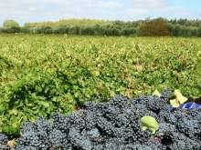
5-Embroidery

Alongside the craft of the seamstress, it is also the art of embroidery. Often it is performed for the preparation of the dowry of the girls of the family, but it is not rare to find those who embroider for the rich ladies of the town and the nearby capital, thus contributing to the scarce family finances. The embroidery work takes place, according to the extension of the garment to be embroidered, or in a long "tilaru" frame, in which one works with four hands, or in a manageable frame formed by two concentric circles, with a diameter of about 30 cm , in which the fabric of variable thickness is inserted but never again. The points that were most performed in the area are: (the so-called paraded points) 400, 500 the 700; the carving point; the rhodes point; the cross-stitch; the picturesque; the Norwegian point. Also to be mentioned together with these challenging points; grilling, with which stockings and sweaters are made for the whole family, and crochet work, which is a small iron about 25 cm long and of variable thickness but never more than 3 mm thick, with which you can also make beautiful double bedspreads.

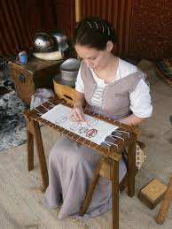
6-Reapers and gleaners

The two activities, harvest and gleaning, are two seasonal jobs linked to the cultivation of wheat. The area of ​​reference of the research was not a cereal area, when at the end of June the wheat began to be harvested, where it is more cultivated, it is common to see the migration of many "viddana" farmers towards the cereal areas, attracted by a congruous gain, which makes us forget the immense fatigue of work and the distance, even if temporary, from our dearest affections, to the work of the harvest follows the most humble, but no less laborious work than the sharpening, which consisted in collecting the ears that remain on the ground outside the sheaves of wheat, these two phases are followed by the threshing of the ears to divide the grain from the straw (spagliari). The harvest is reserved above all for those forage essences that constitute the essential supply for the prosperous farms in the area.

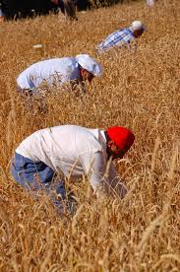
7-Beekeeper
The work is concentrated in 5-6 months, depending on the climate. In the first phase, the “families” of bees are looked after, it is checked that they are healthy, that for every hive the queen is always active and that there is enough food. Finally we move on to the honey extraction: the wax frames are extracted on which the insects build the honeycomb and fill it with honey and are taken to the laboratory.
Here, the machines do the rest. And the honey is ready. It seems easy, in fact it is, just follow all the steps carefully and accurately.

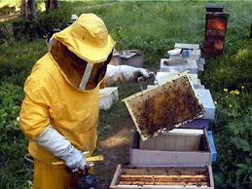
8-The ceramist
The ceramist is an artist or an employee who produces ceramics or decorates them. The work of ceramist requires skill and mastery to accurately follow every phase of the production of ceramics and obtain the desired results in the phases of: forming, drying, first firing, decoration, second fire.
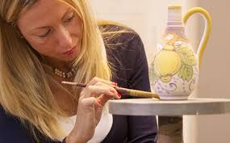
9-Dairy Worker

He is the one who takes care of the production of cheese inside establishments
special for processing dairy products, also called dairies. The employee of
Caseificio is a professional figure that can operate on all phases of
production of the product, following precise instructions. The work follows from
milk collection at the processing, pasteurization, skimming stages,
curd processing, salting and seasoning. In relation to the type and the
size of the establishment, which may vary depending on eg
cheese produced, dairy workers can have different tasks. In
small and medium-sized or artisan companies, the employees take care of all the phases of
cheese processing. In industrial plants the employees
they follow only one or some of these phases and in the case in which the company heals
even the public sale of its products, the employees can take care of
also contact with customers. Relates to colleagues in the department or
dairy, with the person responsible for the indications on the organization and on the
activities to be carried out, with customers in the event that the sale is foreseen
public.

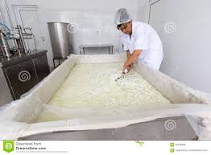
10-olive harvest operator
Olive harvest: This operation can be carried out in different ways:

- Burning: the olives are detached from the branches by the operator's hands and placed in baskets. It is the oldest, slowest, most expensive technique, but it is the best since it is the one that causes the least mechanical stress to the olive and, therefore, affects the quality of the oil present in the olive itself to a lesser extent.
- Combing: the olives are detached from the branches with the help of manual or mechanized combs and the olives fall on nets placed on the ground below the trees;
- Sloping: the foliage of the olive trees is beaten manually or mechanically with the aid of sticks or canes and the olives fall on nets placed on the ground below the trees;
- Brushing: at the end of maturation the olives detach from the branches and fall on the ground in a natural way. The harvest is done with the help of hand or mechanical brooms.

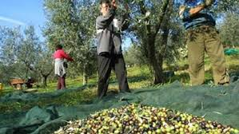
11-Sicilian cart builder
The Sicilian cart itself has very ancient origins: Pindaro was already talking about it; the painted and carved cart, on the other hand, has its roots in the eighteenth-century custom of painting and sculpting litters, carriages and sedan chairs.
The precision of the drawings, together with the creativity of the decorations, make Sicilian carts a real means of communication: the oral tradition of handing down legends of chivalrous epic or saints' stories could not find a better ally in the painting of the cart.
There are few artisans who still hand down the art of the painted cart in Sicily. As Michele Ducato, the last heir of a dynasty of artists in Bagheria.

